https://www.jdoodle.com/embed/v0/5O4e

Output
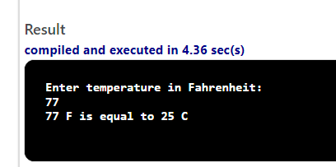

Code:
#include <iostream>

using namespace std;
int main()
{
//Declare variables for keeping temperatures in Fahrenheit and Centigrade
double f, c;

//Input temperature in Fahrenheit

cout << "Enter temperature in Fahrenheit: " << endl;
cin >> f;

//Convert Fahrenheit temperature in Centigrade
c = (5.0 / 9.0) * (f - 32.0);
cout << f <<" F is equal to " << c <<" C";
return 0;
}

